Using Pixel Shaders With Models

by Steve Messick
Touchdown Entertainment

March 10, 2003

The Jupiter System model interface has been modified to include support for pixel shaders. Pixel shaders can be loaded and applied to all or part of a rigid, skeletal, or blended mesh through an interface that is exposed to your game code. Any resulting questions you may have over this addition can be directed to support@touchdownentertainment.com

What is a Pixel Shader?
A pixel shader is a function that can be executed on each surface in a mesh before that mesh is displayed. Pixel shaders are written using the DirectX pixel shader assembly language and compiled using a pixel shader compiler. There are numerous inputs into a pixel shader including temporary, texture, and constant registers. A pixel shader only outputs r0. Please refer to the DirectX or Xbox XDK documentation for further information regarding pixel shaders.

LTPixelShader
Pixel shaders are represented in the Jupiter System by the LTPixelShader class. An LTPixelShader object contains the following items:

LTPixelShader
property | description
ID | A unique integer ID supplied by the game code when the pixel shader is loaded from file.
Name | The filename of the pixel shader.
Next | The pointer to the next pixel shader that has been loaded. This pointer will be NULL when the end of the list is reached.
Constants | The pixel shader constants provide a way to input data into your pixel shader. These constants get loaded into the pixel shader constant registers before the pixel shader is executed. Each constant register contains four floating-point values. There are 8 constant registers.

Compiling Pixel Shaders
Pixel shaders must be compiled before the Jupiter System can load them. Note that the Xbox pixel shader compiler produces different binaries than the Windows DirectX pixel shader compiler. You cannot load a Windows pixel shader on the Xbox and vice versa. Please consult the DirectX or Xbox XDK documentation for more information about compiling pixel shaders.

Loading Pixel Shaders
Pixel shaders are loaded through the client with ILTClient::AddPixelShader(). This function takes the following inputs:

ILTClient::AddPixelShader()
parameter | description
const char * | Compiled binary pixel shader filename
int | Unique integer ID supplied by the game code

The Xbox allows developers to create pixel shaders by directly filling out the pixel shader microcode in a D3DPIXELSHADERDEF structure. When the pixel shader is loaded into the GPU, it will simply use the microcode that is contained in the D3DPIXELSHADERDEF structure. Creating and loading pixel shaders using this method is much faster than loading the pixel shaders from file. The Jupiter System for Xbox provides an additional ILTClient::AddPixelShader() function for creating pixel shaders using a D3DPIXELSHADERDEF structure:

ILTClient::AddPixelShader()
parameter | description
const char * | Name of the pixel shader. Since this shader is not loaded from file, the name can be anything.
int | Unique integer ID supplied by the game code
D3DPIXELSHADERDEF * | Pointer to a pixel shader definition structure. This structure must be filled out by the game code before it is sent to the AddPixelShader() function. The LTPixelShader class will make a copy of the structure to keep it persistent. The D3DPIXELSHADERDEF structure can be accessed at any time through LTPixelShader::GetPixelShaderDef().

Applying Pixel Shaders To Models
Pixel shaders are applied to models using RenderStyles. The RenderStylesEditor allows a pixel shader to be assigned for each render pass.

To assign a pixel shader to a render pass, first click the Configure Render Pass 1 button in the RenderStylesEditor. This will bring up the Render Pass Dialog.

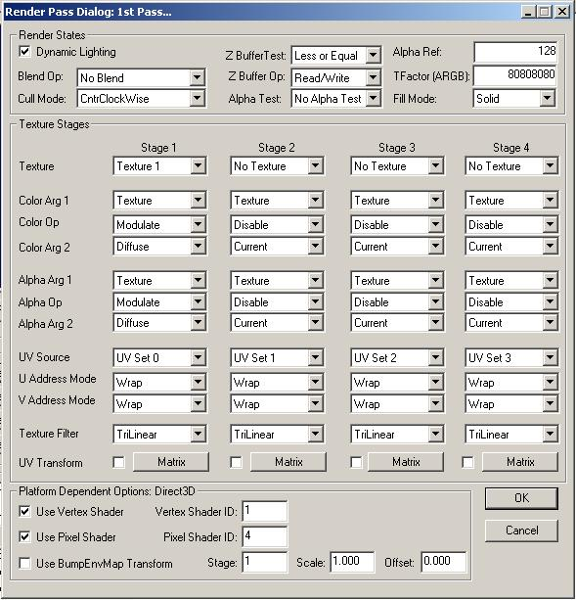

Check the Use Pixel Shader checkbox to enable the pixel shader for this render pass. Set the Pixel Shader ID to the ID that you assign to the shader during the ILTClient::AddPixelShader() function call. Save the RenderStyle and then compile the RenderStyle into a LTB file. See the Jupiter Development Guide for more information about RenderStyles.

The RenderStyle is applied to a model in code when the model object is created using the m_RenderStyleNames array in the ObjectCreateStruct.

If your model has multiple pieces, and you want a different RenderStyle on each piece, then you will need to edit the model in ModelEdit to assign the RenderStyle indices. To assign RenderStyle indices in ModelEdit, first run ModelEdit and open your model’s LTA or LTC file. Click on a piece in the pieces list and then open the Piece menu and select Piece Info. The number in the RenderStyle Index edit box corresponds to the index of the m_RenderStyleNames array in the ObjectCreateStruct.

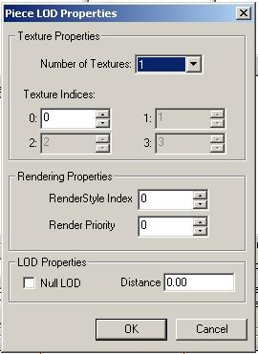

The following code applies the RigidColorBump.ltb RenderStyle to the model:

ObjectCreateStruct ocs;
ocs.Clear();

ocs.m_ObjectType = OT_MODEL;
ocs.m_Flags = FLAG_VISIBLE | FLAG_NOLIGHT;

// model
strcpy(ocs.m_Filename, "Models\\tdsphere.ltb");

// texture
strcpy(ocs.m_SkinNames[0], "ModelTextures\\tdlogo.dtx");

// renderstyles
strcpy(ocs.m_RenderStyleNames[0], "RS\\RigidColorBump.ltb");

// position
ocs.m_Pos.Init(120.0f * (float)Col, 0.0f, 120.0f * (float)Row);

// Create the object.
HLOCALOBJ hObj = g_pLTClient->CreateObject(&ocs);

Getting Your Data Into a Pixel Shader
Now that you have loaded a pixel shader and assigned it to a model, you will want to send input data to the pixel shader. Data can be input to your pixel shader through the constant input registers by calling the following functions:

// get the values in a constant register
virtual bool GetConstant(unsigned RegisterNum, float *pf0, float *pf1,
float *pf2, float *pf3);

// set the values in a constant register
virtual bool SetConstant(unsigned RegisterNum, float f0, float f1,
float f2, float f3);

// copies the values in the given matrix to the four constant registers
// starting at RegisterNum
virtual bool SetConstant(unsigned RegisterNum, const LTMatrix &Matrix);

// get the constant array, there are 4 floats per register
virtual float* GetConstants();

// get the number of constants, there are 4 floats per register
unsigned GetNumConstants();

There are 8 constant registers that can be input into a pixel shader, with each register consisting of 4 floating point values. Each LTPixelShader class contains an array of constants (of 4 floats each) that can be modified at any time.

The OnPixelShaderSetConstants() Callback Function
The input constants are sent to the hardware registers each frame just before the model piece is rendered. The IClientShell::OnPixelShaderSetConstants() function is called during rendering just before the constants are sent to the video card. This callback function allows last minute changes to the constants, and allows the game code access to rendering data such as the current world transforms, the current view and projection transforms, the texture transforms, the hardware light settings, and the current camera settings.

virtual void OnPixelShaderSetConstants(
LTPixelShader *pPixelShader, // current shader
unsigned iPass, // current render pass
CRenderStyle *pRenderStyle, // current RenderStyle
HOBJECT hObj, // handle to model object
const LTShaderDeviceState &ShaderDeviceState); // access to device settings

Your game code will need to implement this function if you need to send data to your pixel shader. The LTShaderDeviceState class provides you with functions for accessing information about the device. Please note that all matrices need to be transposed before being sent to pixel shaders.

// get a matrix from the device
// set Transpose to true to have the matrix transposed
virtual bool GetMatrix(LTMatrixType MatrixType, bool Transpose,
LTMatrix *pMatrix) const;

// get a light from the device
// LightIndex is in the range [0,7]
virtual bool GetLight(unsigned LightIndex, LTLightDesc *pLightDesc) const;

// get the camera from the device
virtual bool GetCamera(LTCameraDesc *pCameraDesc) const;

The following code shows how to send a color to a pixel shader:

pPixelShader->SetConstant(0, m_CurrentColor.x, m_CurrentColor.y,
m_CurrentColor.z, 1.0f);

Example: TDSPHERE
This example uses a simple sphere model with a texture. The vertex shader applied tho this model will use the normal vector to color the vertices. The pixel shader applied to this model will interpolate between an input color and the dot product of the texture and vertex color. The files for this example can be found in the ShaderDemo sample in your Jupiter Technology SDK.



We decide to create a pixel shader that will use the model’s texture as if it were a bump map. The resulting color will be a linear interpolation between an input color and the vertex color using the bump map as the percentage of interpolation. Our pixel shader (WinColorLerp.vsh) is as follows:

; WinColorLerp.psh
; This shader will interpolate between the vertex color and the
; color in c0 using the texture as a bump map.
ps.1.0
;------------------------------------------------------------------------------
; Constants
; c0 = color
;------------------------------------------------------------------------------

tex t0

dp3 r1, t0, v0
lrp r0, r1, c0, v0

The pixel shader is then loaded with the following call:

#define PIXELSHADER_COLORLERP 0

// color lerp
if (!g_pLTClient->AddPixelShader(“WinColorLerp.pso”, PIXELSHADER_COLORLERP))
{
return LT_ERROR;
}

Now that the shader has been loaded, we need to set the shader constants. In the OnPixelShaderSetConstants() callback function. We will only need to pass in the color.

switch (pPixelShader->GetID())
{
case PIXELSHADER_COLORLERP:
pPixelShader->SetConstant(0, m_CurrentColor.x,
m_CurrentColor.y,
m_CurrentColor.z, 1.0f);
break;
}

Finally, we need to load the appropriate RenderStyle that uses this shader.

ObjectCreateStruct ocs;
ocs.Clear();

ocs.m_ObjectType = OT_MODEL;
ocs.m_Flags = FLAG_VISIBLE;

// model
strcpy(ocs.m_Filename, "Models\\tdsphere.ltb");

// texture
strcpy(ocs.m_SkinNames[0], "ModelTextures\\tdlogo.dtx");

// renderstyle
strcpy(ocs.m_RenderStyleNames[0], " RS\\RigidColorLerp.ltb");

// position
ocs.m_Pos.Init(120.0f * (float)Col, 0.0f, 120.0f * (float)Row);

// Create the object.
HLOCALOBJ hObj = g_pLTClient->CreateObject(&ocs);
m_hModels[Row][Col] = hObj;

